APPLICATION OF CONVERSION OF DECIMAL TO OCTAL

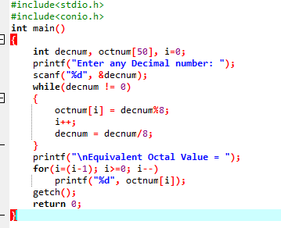

OUTPUT

